МІНІСТЕРСТВО ОСВІТИ І НАУКИ УКРАЇНИ

«КИЇВСЬКИЙ ПОЛІТЕХНІЧНИЙ ІНСТИТУТ імені ІГОРЯ СІКОРСЬКОГО»

ФАКУЛЬТЕТ ІНФОРМАТИКИ ТА ОБЧИСЛЮВАЛЬНОЇ ТЕХНІКИ

Кафедра інформатики та програмної інженерії

**Звіт**

З лабораторної роботи № 4 з дисципліни

«Програмування комп'ютерної графіки»

«**Моделювання освітлення**»

| **Виконав(ла)** | *ІП-13 Бабіч Денис* |  |  |
| --- | --- | --- | --- |
|  | (шифр, прізвище, ім'я, по батькові) |  |  |

| **Перевірив(ла)** | *Порєв В. М.* |  |  |
| --- | --- | --- | --- |
|  | (посада, прізвище, ім'я, по батькові) |  |  |

Київ 2025

# ОСНОВНА ЧАСТИНА

**Мета роботи**: Отримати навички програмування освітлення тривимірних

об’єктів засобами графіки OpenGL ES.

**Завдання**:

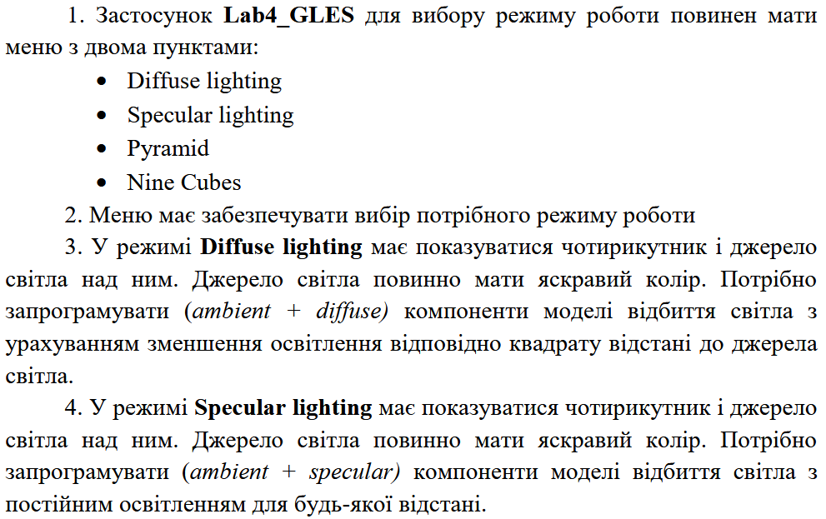

Рисунок 1.1 – Завдання лабораторної роботи

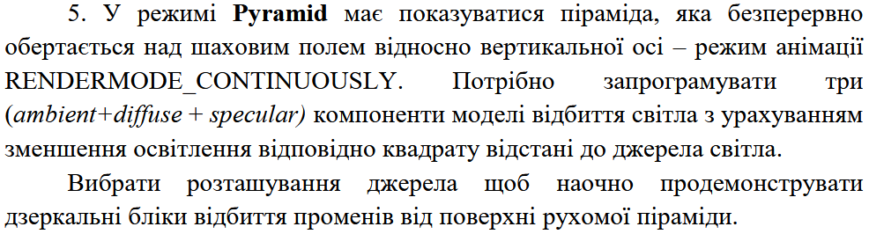

Рисунок 1.2 – Завдання лабораторного практикуму

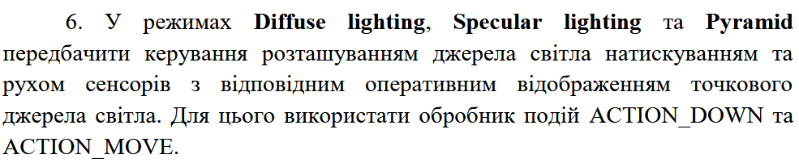

Рисунок 1.3 – Завдання лабораторного практикуму

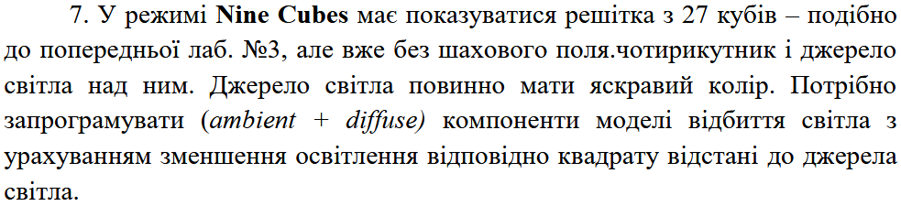

Рисунок 1.4 – Завдання лабораторного практикуму

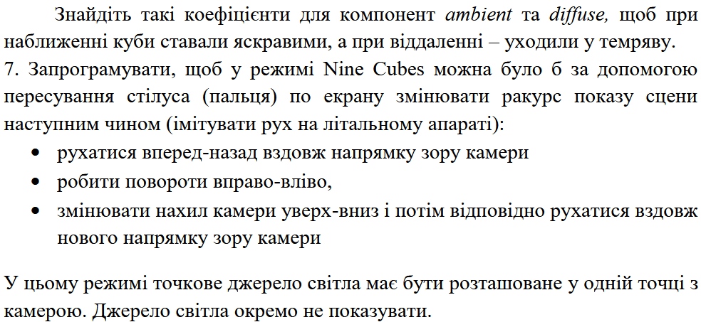

Рисунок 1.5 – Завдання лабораторного практикуму

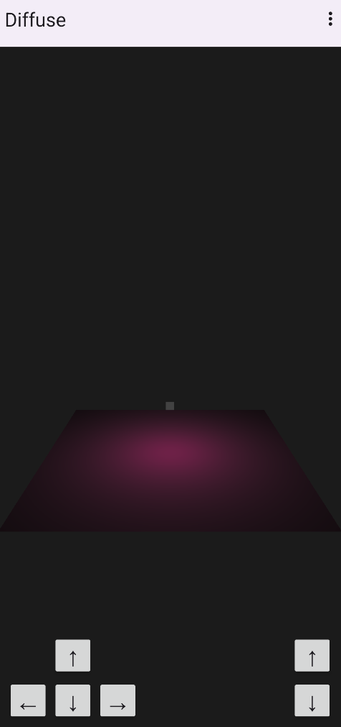

Рисунок 1.6 – Приклад сцени з дифузним світлом

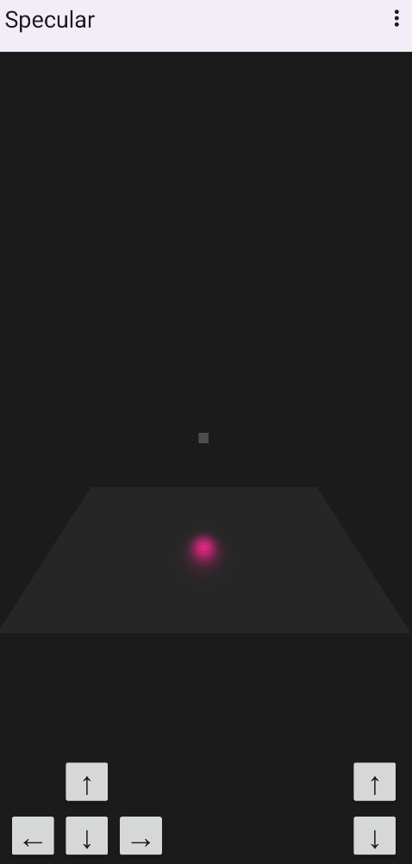

Рисунок 1.7 – Приклад сцени зі спекулярним світлом

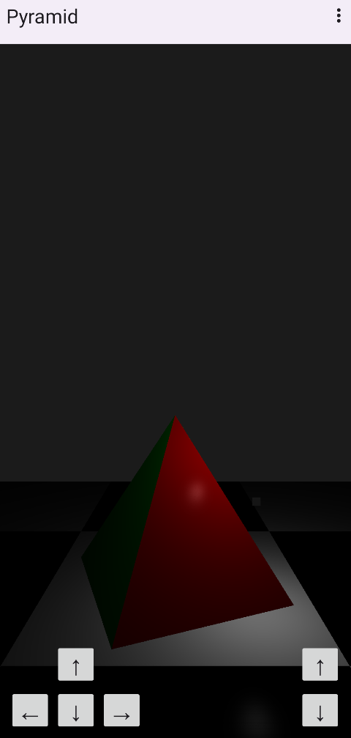

Рисунок 1.8 – Сцена з пірамідою та освітленням

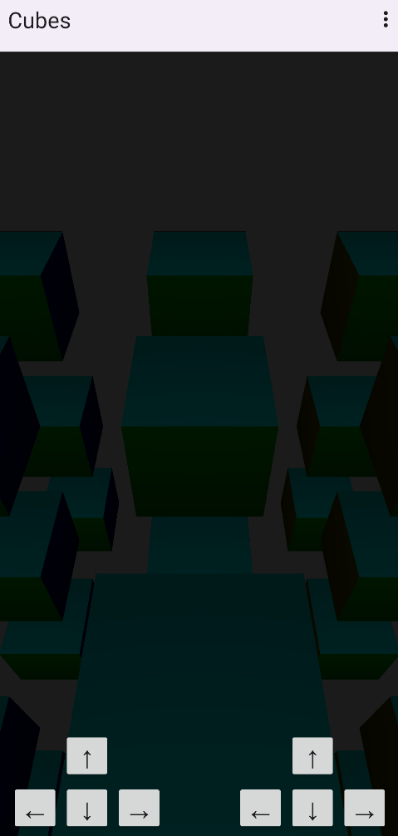

Рисунок 1.9 – Сцена з кубами

**Component.java**

package com.labwork.texturesexample.core.components.common;

import com.labwork.texturesexample.core.general.Entity;

public class Component {

private static int nextId;

private final int id;

private final Entity entity;

private boolean isActive;

public Component(Entity entity) {

this.entity = entity;

this.id = ++Component.nextId;

}

public int getId() {

return this.id;

}

public Entity getEntity() {

return this.entity;

}

public boolean getIsActive() {

return this.isActive;

}

public void setIsActive(boolean value) {

this.isActive = value;

}

public void onStart() {}

public void onUpdate(float deltaTime) {}

public void onDestroy() {}

}

**CameraComponent.java**

package com.labwork.texturesexample.core.components.concrete;

import android.opengl.Matrix;

import com.labwork.texturesexample.core.general.Color;

import com.labwork.texturesexample.core.general.Entity;

import com.labwork.texturesexample.core.components.common.Component;

public class CameraComponent extends Component {

private static final int MATRIX_DIMENSIONS_COUNT = 16;

protected final float[] matrixView;

protected final float[] matrixProjection;

protected Color backgroundColor;

protected float farClippingPlane;

protected float nearClippingPlane;

public CameraComponent(Entity entity, Color color, float nearClippingPlane, float farClippingPlane) {

super(entity);

this.backgroundColor = color;

this.farClippingPlane = farClippingPlane;

this.nearClippingPlane = nearClippingPlane;

this.matrixView = new float[CameraComponent.MATRIX_DIMENSIONS_COUNT];

this.matrixProjection = new float[CameraComponent.MATRIX_DIMENSIONS_COUNT];

Matrix.setIdentityM(this.matrixView, 0);

Matrix.setIdentityM(this.matrixProjection, 0);

}

public float[] getMatrixView() {

return this.matrixView;

}

public float[] getMatrixProjection() {

return this.matrixProjection;

}

public Color getBackgroundColor() {

return this.backgroundColor;

}

public void setBackgroundColor(Color value) {

this.backgroundColor = value;

}

public float getFarClippingPlane() {

return this.farClippingPlane;

}

public void setFarClippingPlane(float value) {

this.farClippingPlane = value;

}

public float getNearClippingPlane() {

return this.nearClippingPlane;

}

public void setNearClippingPlane(float value) {

this.nearClippingPlane = value;

}

}

**CameraPerspectiveComponent.java**

package com.labwork.texturesexample.core.components.concrete;

import android.opengl.GLES32;

import android.opengl.Matrix;

import android.opengl.GLSurfaceView;

import com.labwork.texturesexample.runtime.Framework;

import com.labwork.texturesexample.core.general.Color;

import com.labwork.texturesexample.core.general.Entity;

import com.labwork.texturesexample.core.general.Vector3;

public final class CameraPerspectiveComponent extends CameraComponent {

private final Vector3 target;

private final GLSurfaceView viewport;

private Vector3 up;

private Vector3 position;

private float aspectRatio;

private float fieldOfView;

private TransformComponent transform;

public CameraPerspectiveComponent(Entity entity, Color color, float nearClippingPlane, float farClippingPlane, float aspectRatio, float fieldOfView) {

super(entity, color, nearClippingPlane, farClippingPlane);

this.viewport = Framework.getInstance().getSurfaceView();

this.fieldOfView = fieldOfView;

this.aspectRatio = aspectRatio;

this.up = new Vector3(0.0f, 1.0f, 0.0f);

this.target = new Vector3(0.0f, 0.0f, 1.0f);

this.position = new Vector3(0.0f, 0.0f, 0.0f);

}

public float getAspectRatio() {

return this.aspectRatio;

}

public void setAspectRatio(float value) {

this.aspectRatio = value;

}

public float getFieldOfView() {

return this.fieldOfView;

}

public void setFieldOfView(float value) {

this.fieldOfView = value;

}

@Override

public void onStart() {

this.transform = super.getEntity().getComponent(TransformComponent.class);

this.up = this.transform.getUp();

this.position = this.transform.getPosition();

}

@Override

public void onUpdate(float deltaTime) {

this.setAspectRatio((float)this.viewport.getWidth() / this.viewport.getHeight());

GLES32.glClearColor(super.backgroundColor.getRNormalized(), super.backgroundColor.getGNormalized(), super.backgroundColor.getBNormalized(), super.backgroundColor.getANormalized());

Vector3.add(this.transform.getPosition(), this.transform.getForward(), this.target);

Matrix.perspectiveM(super.matrixProjection, 0, this.fieldOfView, this.aspectRatio, super.nearClippingPlane, super.farClippingPlane);

Matrix.setLookAtM(super.matrixView, 0, this.position.getX(), this.position.getY(), this.position.getZ(), this.target.getX(), this.target.getY(), this.target.getZ(), this.up.getX(), this.up.getY(), this.up.getZ());

}

}

**LightComponent.java**

package com.labwork.illuminationexample.core.components.concrete;

import android.opengl.GLES32;

import com.labwork.illuminationexample.core.general.Color;

import com.labwork.illuminationexample.core.general.Entity;

import com.labwork.illuminationexample.core.general.Shader;

import com.labwork.illuminationexample.core.general.Vector3;

import com.labwork.illuminationexample.core.components.common.Component;

public final class LightComponent extends Component {

private Color color;

private Shader shader;

private float intensity;

private boolean isDistanceDependent;

private TransformComponent transform;

public LightComponent(Entity entity, Shader shader, Color color, float intensity, boolean isDistanceDependent) {

super(entity);

this.color = color;

this.shader = shader;

this.intensity = intensity;

this.isDistanceDependent = isDistanceDependent;

}

public Color getColor() {

return this.color;

}

public void setColor(Color value) {

this.color = value;

}

public float getIntensity() {

return this.intensity;

}

public void setIntensity(float value) {

this.intensity = value;

}

@Override

public void onStart() {

this.transform = super.getEntity().getComponent(TransformComponent.class);

}

public void render() {

GLES32.glUniform1f(this.shader.getVariableHandler("uLightPropertyIntensity"), this.intensity);

GLES32.glUniform1i(this.shader.getVariableHandler("uIsDistanceDependent"), this.isDistanceDependent ? 1 : 0);

GLES32.glUniform4f(this.shader.getVariableHandler("uLightPropertyColorRGBA"), this.color.getRNormalized(), this.color.getGNormalized(), this.color.getBNormalized(), this.color.getANormalized());

Vector3 position = this.transform.getPosition();

GLES32.glUniform3f(this.shader.getVariableHandler("uTransformLightPositionGlobal"), position.getX(), position.getY(), position.getZ());

}

}

**OpaqueRenderingComponent.java**

package com.labwork.texturesexample.core.components.concrete;

import android.opengl.GLES32;

import com.labwork.texturesexample.core.general.Mesh;

import com.labwork.texturesexample.core.general.Color;

import com.labwork.texturesexample.core.general.Entity;

import com.labwork.texturesexample.core.general.Shader;

import com.labwork.texturesexample.core.general.Material;

import com.labwork.texturesexample.core.components.common.Component;

public final class OpaqueRenderingComponent extends Component {

private static final int TEXTURE_UNIT_INDEX_OPAQUE = 0;

private Mesh mesh;

private Material material;

private TransformComponent transform;

public OpaqueRenderingComponent(Entity entity, Mesh mesh, Material material) {

super(entity);

this.mesh = mesh;

this.material = material;

}

public Mesh getMesh() {

return this.mesh;

}

public void setMesh(Mesh value) {

this.mesh = value;

}

public Material getMaterial() {

return this.material;

}

public void setMaterial(Material value) {

this.material = value;

}

@Override

public void onStart() {

this.transform = super.getEntity().getComponent(TransformComponent.class);

}

public void render() {

Shader shader = this.material.getShader();

GLES32.glUniformMatrix4fv(shader.getVariableHandler("uMatrixModel"), 1, false, this.transform.getMatrixModel(), 0);

Color color = this.material.getColor();

GLES32.glUniform4f(shader.getVariableHandler("uMaterialColorRGBA"), color.getRNormalized(), color.getGNormalized(), color.getBNormalized(), color.getANormalized());

GLES32.glBindTexture(GLES32.GL_TEXTURE_2D, this.material.getTextureAlbedo().getId());

GLES32.glUniform1i(shader.getVariableHandler("uTextureAlbedo"), OpaqueRenderingComponent.TEXTURE_UNIT_INDEX_OPAQUE);

this.mesh.draw();

}

}

**TransformComponent.java**

package com.labwork.texturesexample.core.components.concrete;

import android.opengl.Matrix;

import com.labwork.texturesexample.core.general.Axis;

import com.labwork.texturesexample.core.general.Entity;

import com.labwork.texturesexample.core.general.Vector3;

import com.labwork.texturesexample.core.components.common.Component;

public final class TransformComponent extends Component {

private static final int MATRIX_OUTPUT_DIMENSIONS_COUNT = 16;

private static final int MATRIX_INTERMEDIATE_DIMENSIONS_COUNT = 4;

private static final float[] MATRIX_VECTOR_UP = { 0.0f, 1.0f, 0.0f, 0.0f };

private static final float[] MATRIX_VECTOR_RIGHT = { 1.0f, 0.0f, 0.0f, 0.0f };

private static final float[] MATRIX_VECTOR_FORWARD = { 0.0f, 0.0f, 1.0f, 0.0f };

private final Vector3 scale;

private final Vector3 rotation;

private final Vector3 position;

private final Vector3 vectorUp;

private final Vector3 vectorRight;

private final Vector3 vectorForward;

private final float[] matrixModel;

private final float[] matrixRotation;

private final float[] matrixRotationOutput;

public TransformComponent(Entity entity) {

super(entity);

this.matrixModel = new float[TransformComponent.MATRIX_OUTPUT_DIMENSIONS_COUNT];

this.matrixRotation = new float[TransformComponent.MATRIX_OUTPUT_DIMENSIONS_COUNT];

this.matrixRotationOutput = new float[TransformComponent.MATRIX_INTERMEDIATE_DIMENSIONS_COUNT];

this.scale = new Vector3(1.0f, 1.0f, 1.0f);

this.rotation = new Vector3(0.0f, 0.0f, 0.0f);

this.position = new Vector3(0.0f, 0.0f, 0.0f);

this.vectorUp = new Vector3(0.0f, 0.0f, 0.0f);

this.vectorRight = new Vector3(0.0f, 0.0f, 0.0f);

this.vectorForward = new Vector3(0.0f, 0.0f, 0.0f);

}

public Vector3 getScale() {

return this.scale;

}

public void setScale(Vector3 value) {

this.scale.setX(value.getX());

this.scale.setY(value.getY());

this.scale.setZ(value.getZ());

}

public Vector3 getRotation() {

return this.rotation;

}

public void setRotation(Vector3 value) {

this.rotation.setX(value.getX());

this.rotation.setY(value.getY());

this.rotation.setZ(value.getZ());

}

public Vector3 getPosition() {

return this.position;

}

public void setPosition(Vector3 value) {

this.position.setX(value.getX());

this.position.setY(value.getY());

this.position.setZ(value.getZ());

}

public float[] getMatrixModel() {

Matrix.setIdentityM(this.matrixModel, 0);

Matrix.scaleM(this.matrixModel, 0, this.scale.getX(), this.scale.getY(), this.scale.getZ());

Matrix.rotateM(this.matrixModel, 0, this.rotation.getZ(), 0.0f, 0.0f, 1.0f);

Matrix.rotateM(this.matrixModel, 0, this.rotation.getY(), 0.0f, 1.0f, 0.0f);

Matrix.rotateM(this.matrixModel, 0, this.rotation.getX(), 1.0f, 0.0f, 0.0f);

Matrix.translateM(this.matrixModel, 0, this.position.getX(), this.position.getY(), this.position.getZ());

return this.matrixModel;

}

public Vector3 getUp() {

Matrix.multiplyMV(this.matrixRotationOutput, 0, this.getRotationMatrix(), 0, TransformComponent.MATRIX_VECTOR_UP, 0);

this.vectorUp.setX(this.matrixRotationOutput[Axis.X.ordinal()]);

this.vectorUp.setY(this.matrixRotationOutput[Axis.Y.ordinal()]);

this.vectorUp.setZ(this.matrixRotationOutput[Axis.Z.ordinal()]);

Vector3.normalize(this.vectorUp, this.vectorUp);

return this.vectorUp;

}

public Vector3 getRight() {

Matrix.multiplyMV(this.matrixRotationOutput, 0, this.getRotationMatrix(), 0, TransformComponent.MATRIX_VECTOR_RIGHT, 0);

this.vectorRight.setX(this.matrixRotationOutput[Axis.X.ordinal()]);

this.vectorRight.setY(this.matrixRotationOutput[Axis.Y.ordinal()]);

this.vectorRight.setZ(this.matrixRotationOutput[Axis.Z.ordinal()]);

Vector3.normalize(this.vectorRight, this.vectorRight);

return this.vectorRight;

}

public Vector3 getForward() {

Matrix.multiplyMV(this.matrixRotationOutput, 0, this.getRotationMatrix(), 0, TransformComponent.MATRIX_VECTOR_FORWARD, 0);

this.vectorForward.setX(this.matrixRotationOutput[Axis.X.ordinal()]);

this.vectorForward.setY(this.matrixRotationOutput[Axis.Y.ordinal()]);

this.vectorForward.setZ(this.matrixRotationOutput[Axis.Z.ordinal()]);

Vector3.normalize(this.vectorForward, this.vectorForward);

return this.vectorForward;

}

private float[] getRotationMatrix() {

Matrix.setIdentityM(this.matrixRotation, 0);

Matrix.rotateM(this.matrixRotation, 0, this.rotation.getZ(), 0.0f, 0.0f, 1.0f);

Matrix.rotateM(this.matrixRotation, 0, this.rotation.getY(), 0.0f, 1.0f, 0.0f);

Matrix.rotateM(this.matrixRotation, 0, this.rotation.getX(), 1.0f, 0.0f, 0.0f);

return this.matrixRotation;

}

}

**Axis.java**

package com.labwork.texturesexample.core.general;

public enum Axis {

X,

Y,

Z,

}

**Color.java**

package com.labwork.texturesexample.core.general;

public final class Color {

private static final float MAX_CHANNEL_VALUE = 255.0f;

private int r, g, b, a;

private float rNormalized, gNormalized, bNormalized, aNormalized;

public Color(int r, int g, int b, int a) {

this.r = r;

this.g = g;

this.b = b;

this.a = a;

this.rNormalized = r / Color.MAX_CHANNEL_VALUE;

this.gNormalized = g / Color.MAX_CHANNEL_VALUE;

this.bNormalized = b / Color.MAX_CHANNEL_VALUE;

this.aNormalized = a / Color.MAX_CHANNEL_VALUE;

}

public int getR() {

return this.r;

}

public void setR(int value) {

this.r = value;

this.rNormalized = value / Color.MAX_CHANNEL_VALUE;

}

public float getRNormalized() {

return this.rNormalized;

}

public int getG() {

return this.g;

}

public void setG(int value) {

this.g = value;

this.gNormalized = value / Color.MAX_CHANNEL_VALUE;

}

public float getGNormalized() {

return this.gNormalized;

}

public int getB() {

return this.b;

}

public void setB(int value) {

this.b = value;

this.bNormalized = value / Color.MAX_CHANNEL_VALUE;

}

public float getBNormalized() {

return this.bNormalized;

}

public int getA() {

return this.a;

}

public void setA(int value) {

this.a = value;

this.aNormalized = value / Color.MAX_CHANNEL_VALUE;

}

public float getANormalized() {

return this.aNormalized;

}

}

**Entity.java**

package com.labwork.texturesexample.core.general;

import java.util.Map;

import java.util.HashMap;

import java.util.Collection;

import com.labwork.texturesexample.core.components.common.Component;

public class Entity {

private static int nextId;

private final int id;

private final Map<Class<?>, Component> components;

private boolean isActive;

public Entity() {

this.isActive = true;

this.id = ++Entity.nextId;

this.components = new HashMap<>();

}

public int getId() {

return this.id;

}

public boolean getIsActive() {

return this.isActive;

}

public void setIsActive(boolean value) {

this.isActive = value;

}

public Collection<Component> getComponents() {

return this.components.values();

}

public void addComponent(Component component) {

if (this.components.containsKey(component.getClass()))

throw new IllegalArgumentException("Component of type " + component.getClass().getName() + " already exists.");

this.components.put(component.getClass(), component);

}

public boolean hasComponent(Class<?> component) {

return this.components.containsKey(component);

}

@SuppressWarnings("unchecked")

public <T extends Component> T getComponent(Class<T> component) {

return (T) this.components.getOrDefault(component, null);

}

public void onStart() {

for (Component component : this.components.values())

component.onStart();

}

public void onUpdate(float deltaTime) {

for (Component component : this.components.values())

component.onUpdate(deltaTime);

}

public void onDestroy() {

for (Component component : this.components.values())

component.onDestroy();

}

}

**Material.java**

package com.labwork.illuminationexample.core.general;

public final class Material {

private Shader shader;

private Color colorAlbedo;

private float propertyAmbient;

private float propertyDiffuse;

private float propertySpecular;

public Material(Shader shader, Color colorAlbedo, float propertyAmbient, float propertyDiffuse, float propertySpecular) {

this.shader = shader;

this.colorAlbedo = colorAlbedo;

this.propertyAmbient = propertyAmbient;

this.propertyDiffuse = propertyDiffuse;

this.propertySpecular = propertySpecular;

}

public Shader getShader() {

return this.shader;

}

public void setShader(Shader value) {

this.shader = value;

}

public Color getColorAlbedo() {

return this.colorAlbedo;

}

public void setColorAlbedo(Color value) {

this.colorAlbedo= value;

}

public float getPropertyAmbient() {

return this.propertyAmbient;

}

public void setPropertyAmbient(float value) {

this.propertyAmbient = value;

}

public float getPropertyDiffuse() {

return this.propertyDiffuse;

}

public void setPropertyDiffuse(float value) {

this.propertyDiffuse = value;

}

public float getPropertySpecular() {

return this.propertySpecular;

}

public void setPropertySpecular(float value) {

this.propertySpecular = value;

}

}

**Mesh.java**

package com.labwork.illuminationexample.core.general;

import java.nio.ByteOrder;

import java.nio.ByteBuffer;

import java.nio.FloatBuffer;

import android.opengl.GLES32;

public final class Mesh {

private static int HANDLERS_COUNT = 2;

private static int HANDLER_INDEX_VAO = 0;

private static int HANDLER_INDEX_VBO = 1;

public static final int PAYLOAD_POSITION_SIZE = 3;

public static final int PAYLOAD_POSITION_INDEX = 0;

public static final int PAYLOAD_POSITION_OFFSET = 0;

public static final int PAYLOAD_COLOR_SIZE = 4;

public static final int PAYLOAD_COLOR_INDEX = 1;

public static final int PAYLOAD_COLOR_OFFSET = Mesh.PAYLOAD_POSITION_SIZE * Float.BYTES;

public static final int PAYLOAD_NORMAL_SIZE = 3;

public static final int PAYLOAD_NORMAL_INDEX = 2;

public static final int PAYLOAD_NORMAL_OFFSET = (Mesh.PAYLOAD_POSITION_SIZE + Mesh.PAYLOAD_COLOR_SIZE) * Float.BYTES;

public static final int PAYLOAD_STRIDE = (Mesh.PAYLOAD_POSITION_SIZE + Mesh.PAYLOAD_COLOR_SIZE + Mesh.PAYLOAD_NORMAL_SIZE) * Float.BYTES;

private final int drawingMode;

private final int verticesCount;

private final float[] verticesData;

private final int[] bindingHandlers;

public Mesh(float[] verticesData, int drawingMode) {

this.drawingMode = drawingMode;

this.verticesData = verticesData;

this.bindingHandlers = new int[Mesh.HANDLERS_COUNT];

this.verticesCount = verticesData.length / (Mesh.PAYLOAD_POSITION_SIZE + Mesh.PAYLOAD_COLOR_SIZE);

FloatBuffer vertexBuffer = ByteBuffer.allocateDirect(this.verticesData.length * Float.BYTES).order(ByteOrder.nativeOrder()).asFloatBuffer();

vertexBuffer.put(this.verticesData).position(0);

GLES32.glGenVertexArrays(1, this.bindingHandlers, Mesh.HANDLER_INDEX_VAO);

GLES32.glGenBuffers(1, this.bindingHandlers, Mesh.HANDLER_INDEX_VBO);

GLES32.glBindVertexArray(this.bindingHandlers[Mesh.HANDLER_INDEX_VAO]);

GLES32.glBindBuffer(GLES32.GL_ARRAY_BUFFER, this.bindingHandlers[Mesh.HANDLER_INDEX_VBO]);

GLES32.glBufferData(GLES32.GL_ARRAY_BUFFER, this.verticesData.length * Float.BYTES, vertexBuffer, GLES32.GL_STATIC_DRAW);

GLES32.glVertexAttribPointer(Mesh.PAYLOAD_POSITION_INDEX, Mesh.PAYLOAD_POSITION_SIZE, GLES32.GL_FLOAT, false, Mesh.PAYLOAD_STRIDE, Mesh.PAYLOAD_POSITION_OFFSET);

GLES32.glEnableVertexAttribArray(Mesh.PAYLOAD_POSITION_INDEX);

GLES32.glVertexAttribPointer(Mesh.PAYLOAD_COLOR_INDEX, Mesh.PAYLOAD_COLOR_SIZE, GLES32.GL_FLOAT, false, Mesh.PAYLOAD_STRIDE, Mesh.PAYLOAD_COLOR_OFFSET);

GLES32.glEnableVertexAttribArray(Mesh.PAYLOAD_COLOR_INDEX);

GLES32.glVertexAttribPointer(Mesh.PAYLOAD_NORMAL_INDEX, Mesh.PAYLOAD_NORMAL_SIZE, GLES32.GL_FLOAT, false, Mesh.PAYLOAD_STRIDE, Mesh.PAYLOAD_NORMAL_OFFSET);

GLES32.glEnableVertexAttribArray(Mesh.PAYLOAD_NORMAL_INDEX);

GLES32.glBindVertexArray(0);

GLES32.glEnableVertexAttribArray(0);

GLES32.glBindBuffer(GLES32.GL_ARRAY_BUFFER, 0);

}

public void draw() {

GLES32.glBindVertexArray(this.bindingHandlers[Mesh.HANDLER_INDEX_VAO]);

GLES32.glDrawArrays(this.drawingMode, 0, this.verticesCount);

GLES32.glBindVertexArray(0);

}

public void delete() {

GLES32.glDeleteBuffers(this.bindingHandlers.length, this.bindingHandlers, 0);

}

}

**Scene.java**

package com.labwork.texturesexample.core.general;

import java.util.List;

import java.util.ArrayList;

import java.util.Collection;

import com.labwork.texturesexample.core.components.common.Component;

import com.labwork.texturesexample.core.components.concrete.CameraComponent;

import com.labwork.texturesexample.core.components.concrete.SkyboxRenderingComponent;

public final class Scene {

private final List<Entity> entities;

private CameraComponent camera;

private SkyboxRenderingComponent skybox;

public Scene() {

this.entities = new ArrayList<>();

}

public List<Entity> getEntities() {

return this.entities;

}

public CameraComponent getCamera() {

return this.camera;

}

public SkyboxRenderingComponent getSkybox() {

return this.skybox;

}

public void addEntity(Entity entity) {

this.entities.add(entity);

Collection<Component> components = entity.getComponents();

for (Component component : components) {

if (component instanceof CameraComponent) {

this.camera = (CameraComponent) component;

}

if (component instanceof SkyboxRenderingComponent) {

this.skybox = (SkyboxRenderingComponent) component;

}

}

}

public void onUnloaded() {

for (Entity entity: this.entities)

entity.onDestroy();

}

}

**Shader.java**

package com.labwork.texturesexample.core.general;

import android.opengl.GLES32;

public final class Shader {

private final int vertId;

private final int fragId;

private final int programId;

private final Class<?> renderFeature;

public Shader(Class<?> renderFeature, String sourceVert, String sourceFrag) {

this.renderFeature = renderFeature;

this.programId = GLES32.glCreateProgram();

this.vertId = GLES32.glCreateShader(GLES32.GL_VERTEX_SHADER);

GLES32.glShaderSource(this.vertId, sourceVert);

this.fragId = GLES32.glCreateShader(GLES32.GL_FRAGMENT_SHADER);

GLES32.glShaderSource(this.fragId, sourceFrag);

GLES32.glCompileShader(this.vertId);

GLES32.glCompileShader(this.fragId);

GLES32.glAttachShader(this.programId, this.vertId);

GLES32.glAttachShader(this.programId, this.fragId);

GLES32.glBindAttribLocation(this.programId, Mesh.PAYLOAD_COLOR_INDEX, "aVertexColorRGB");

GLES32.glBindAttribLocation(this.programId, Mesh.PAYLOAD_NORMAL_INDEX, "aVertexNormalLocal");

GLES32.glBindAttribLocation(this.programId, Mesh.PAYLOAD_POSITION_INDEX, "aVertexPositionLocal");

GLES32.glBindAttribLocation(this.programId, Mesh.PAYLOAD_TEXTURE_INDEX, "aVertexTextureCoordinate");

GLES32.glLinkProgram(this.programId);

}

public int getId() {

return this.programId;

}

public Class<?> getRenderFeature() {

return this.renderFeature;

}

public int getVariableHandler(String identifier) {

return GLES32.glGetUniformLocation(this.programId, identifier);

}

public void delete() {

GLES32.glDetachShader(this.programId, this.vertId);

GLES32.glDetachShader(this.programId, this.fragId);

GLES32.glDeleteShader(this.vertId);

GLES32.glDeleteShader(this.fragId);

GLES32.glDeleteProgram(this.programId);

}

}

**Vector3.java**

package com.labwork.texturesexample.core.general;

public final class Vector3 {

private float x;

private float y;

private float z;

public Vector3(float x, float y, float z) {

this.x = x;

this.y = y;

this.z = z;

}

public float getX() {

return this.x;

}

public void setX(float value) {

this.x = value;

}

public float getY() {

return this.y;

}

public void setY(float value) {

this.y = value;

}

public float getZ() {

return this.z;

}

public void setZ(float value) {

this.z = value;

}

public void setXYZ(float x, float y, float z) {

this.x = x;

this.y = y;

this.z = z;

}

public float getMagnitude() {

return (float) Math.sqrt(this.x * this.x + this.y * this.y + this.z * this.z);

}

public static float dot(Vector3 a, Vector3 b) {

return a.x * b.x + a.y * b.y + a.z * b.z;

}

public static void add(Vector3 a, Vector3 b, Vector3 output) {

output.x = a.x + b.x;

output.y = a.y + b.y;

output.z = a.z + b.z;

}

public static void subtract(Vector3 a, Vector3 b, Vector3 output) {

output.x = a.x - b.x;

output.y = a.y - b.y;

output.z = a.z - b.z;

}

public static void multiply(Vector3 a, float scalar, Vector3 output) {

output.x = a.x * scalar;

output.y = a.y * scalar;

output.z = a.z * scalar;

}

public static void cross(Vector3 a, Vector3 b, Vector3 output) {

output.x = a.y * b.z - a.z * b.y;

output.y = a.z * b.x - a.x * b.z;

output.z = a.x * b.y - a.y * b.x;

}

public static void normalize(Vector3 a, Vector3 output) {

float magnitude = (float) Math.sqrt(a.x * a.x + a.y * a.y + a.z * a.z);

if (magnitude == 0) {

output.x = 0;

output.y = 0;

output.z = 0;

} else {

output.x = a.x / magnitude;

output.y = a.y / magnitude;

output.z = a.z / magnitude;

}

}

}

**DynamicLightControllerComponent.java**

package com.labwork.texturesexample.demo.components;

import android.view.View;

import android.view.MotionEvent;

import android.widget.Button;

import android.widget.RelativeLayout;

import android.widget.RelativeLayout.LayoutParams;

import com.labwork.texturesexample.runtime.Framework;

import com.labwork.texturesexample.core.general.Entity;

import com.labwork.texturesexample.core.general.Vector3;

import com.labwork.texturesexample.core.components.common.Component;

import com.labwork.texturesexample.core.components.concrete.TransformComponent;

public final class DynamicLightControllerComponent extends Component {

private static final float MOVEMENT_SPEED = 1.0f;

private TransformComponent transform;

private boolean isMovingLeft;

private boolean isMovingRight;

private boolean isMovingForward;

private boolean isMovingBackward;

private boolean isMovingUp;

private boolean isMovingDown;

private final Button buttonMoveLeft;

private final Button buttonMoveRight;

private final Button buttonMoveForward;

private final Button buttonMoveBackward;

private final Button buttonMoveUp;

private final Button buttonMoveDown;

public DynamicLightControllerComponent(Entity entity, Button buttonMoveForward, Button buttonMoveBackward, Button buttonMoveLeft, Button buttonMoveRight, Button buttonMoveUp, Button buttonMoveDown) {

super(entity);

int spacing = 10;

int leftOffset = 50;

int rightOffset = 50;

int buttonSize = 125;

int bottomOffset = 150;

float textSize = 30.0f;

buttonMoveLeft.setVisibility(View.INVISIBLE);

buttonMoveRight.setVisibility(View.INVISIBLE);

buttonMoveForward.setVisibility(View.INVISIBLE);

buttonMoveBackward.setVisibility(View.INVISIBLE);

buttonMoveUp.setVisibility(View.INVISIBLE);

buttonMoveDown.setVisibility(View.INVISIBLE);

this.buttonMoveLeft = buttonMoveLeft;

buttonMoveLeft.setId(View.generateViewId());

buttonMoveLeft.setPadding(0, 0, 0, 0);

buttonMoveLeft.setText("←");

buttonMoveLeft.setTextSize(textSize);

LayoutParams paramsMoveLeft = new LayoutParams(buttonSize, buttonSize);

paramsMoveLeft.addRule(RelativeLayout.ALIGN_PARENT_BOTTOM);

paramsMoveLeft.addRule(RelativeLayout.ALIGN_PARENT_LEFT);

paramsMoveLeft.leftMargin = leftOffset;

paramsMoveLeft.bottomMargin = bottomOffset;

buttonMoveLeft.setLayoutParams(paramsMoveLeft);

buttonMoveLeft.setOnTouchListener(this::handleMoveLeftButtonTouch);

this.buttonMoveBackward = buttonMoveBackward;

buttonMoveBackward.setId(View.generateViewId());

buttonMoveBackward.setPadding(0, 0, 0, 0);

buttonMoveBackward.setText("↓");

buttonMoveBackward.setTextSize(textSize);

LayoutParams paramsMoveDown = new LayoutParams(buttonSize, buttonSize);

paramsMoveDown.addRule(RelativeLayout.RIGHT_OF, buttonMoveLeft.getId());

paramsMoveDown.addRule(RelativeLayout.ALIGN_PARENT_BOTTOM);

paramsMoveDown.leftMargin = spacing;

paramsMoveDown.bottomMargin = bottomOffset;

buttonMoveBackward.setLayoutParams(paramsMoveDown);

buttonMoveBackward.setOnTouchListener(this::handleMoveBackwardButtonTouch);

this.buttonMoveForward = buttonMoveForward;

buttonMoveForward.setId(View.generateViewId());

buttonMoveForward.setPadding(0, 0, 0, 0);

buttonMoveForward.setText("↑");

buttonMoveForward.setTextSize(textSize);

LayoutParams paramsMoveUp = new LayoutParams(buttonSize, buttonSize);

paramsMoveUp.addRule(RelativeLayout.ABOVE, buttonMoveBackward.getId());

paramsMoveUp.addRule(RelativeLayout.ALIGN_LEFT, buttonMoveBackward.getId());

paramsMoveUp.bottomMargin = spacing;

buttonMoveForward.setLayoutParams(paramsMoveUp);

buttonMoveForward.setOnTouchListener(this::handleMoveForwardButtonTouch);

this.buttonMoveRight = buttonMoveRight;

buttonMoveRight.setId(View.generateViewId());

buttonMoveRight.setPadding(0, 0, 0, 0);

buttonMoveRight.setText("→");

buttonMoveRight.setTextSize(textSize);

LayoutParams paramsMoveRight = new LayoutParams(buttonSize, buttonSize);

paramsMoveRight.addRule(RelativeLayout.RIGHT_OF, buttonMoveBackward.getId());

paramsMoveRight.addRule(RelativeLayout.ALIGN_TOP, buttonMoveBackward.getId());

paramsMoveRight.leftMargin = spacing;

buttonMoveRight.setLayoutParams(paramsMoveRight);

buttonMoveRight.setOnTouchListener(this::handleMoveRightButtonTouch);

this.buttonMoveDown = buttonMoveDown;

buttonMoveDown.setId(View.generateViewId());

buttonMoveDown.setPadding(0, 0, 0, 0);

buttonMoveDown.setText("↓");

buttonMoveDown.setTextSize(textSize);

LayoutParams paramsMoveDownRight = new LayoutParams(buttonSize, buttonSize);

paramsMoveDownRight.addRule(RelativeLayout.ALIGN_PARENT_BOTTOM);

paramsMoveDownRight.addRule(RelativeLayout.ALIGN_PARENT_RIGHT);

paramsMoveDownRight.rightMargin = rightOffset;

paramsMoveDownRight.bottomMargin = bottomOffset;

buttonMoveDown.setLayoutParams(paramsMoveDownRight);

buttonMoveDown.setOnTouchListener(this::handleMoveDownButtonTouch);

this.buttonMoveUp = buttonMoveUp;

buttonMoveUp.setId(View.generateViewId());

buttonMoveUp.setPadding(0, 0, 0, 0);

buttonMoveUp.setText("↑");

buttonMoveUp.setTextSize(textSize);

LayoutParams paramsMoveUpRight = new LayoutParams(buttonSize, buttonSize);

paramsMoveUpRight.addRule(RelativeLayout.ABOVE, buttonMoveDown.getId());

paramsMoveUpRight.addRule(RelativeLayout.ALIGN_LEFT, buttonMoveDown.getId());

paramsMoveUpRight.bottomMargin = spacing;

buttonMoveUp.setLayoutParams(paramsMoveUpRight);

buttonMoveUp.setOnTouchListener(this::handleMoveUpButtonTouch);

Framework.getInstance().getViewport().register(buttonMoveLeft);

Framework.getInstance().getViewport().register(buttonMoveRight);

Framework.getInstance().getViewport().register(buttonMoveForward);

Framework.getInstance().getViewport().register(buttonMoveBackward);

Framework.getInstance().getViewport().register(buttonMoveUp);

Framework.getInstance().getViewport().register(buttonMoveDown);

}

private boolean handleMoveForwardButtonTouch(View view, MotionEvent event) {

switch (event.getAction()) {

case MotionEvent.ACTION_DOWN:

this.isMovingForward = true;

return true;

case MotionEvent.ACTION_UP:

case MotionEvent.ACTION_CANCEL:

this.isMovingForward = false;

return true;

default:

return false;

}

}

private boolean handleMoveBackwardButtonTouch(View view, MotionEvent event) {

switch (event.getAction()) {

case MotionEvent.ACTION_DOWN:

this.isMovingBackward = true;

return true;

case MotionEvent.ACTION_UP:

case MotionEvent.ACTION_CANCEL:

this.isMovingBackward = false;

return true;

default:

return false;

}

}

private boolean handleMoveLeftButtonTouch(View view, MotionEvent event) {

switch (event.getAction()) {

case MotionEvent.ACTION_DOWN:

this.isMovingLeft = true;

return true;

case MotionEvent.ACTION_UP:

case MotionEvent.ACTION_CANCEL:

this.isMovingLeft = false;

return true;

default:

return false;

}

}

private boolean handleMoveRightButtonTouch(View view, MotionEvent event) {

switch (event.getAction()) {

case MotionEvent.ACTION_DOWN:

this.isMovingRight = true;

return true;

case MotionEvent.ACTION_UP:

case MotionEvent.ACTION_CANCEL:

this.isMovingRight = false;

return true;

default:

return false;

}

}

private boolean handleMoveUpButtonTouch(View view, MotionEvent event) {

switch (event.getAction()) {

case MotionEvent.ACTION_DOWN:

this.isMovingUp = true;

return true;

case MotionEvent.ACTION_UP:

case MotionEvent.ACTION_CANCEL:

this.isMovingUp = false;

return true;

default:

return false;

}

}

private boolean handleMoveDownButtonTouch(View view, MotionEvent event) {

switch (event.getAction()) {

case MotionEvent.ACTION_DOWN:

this.isMovingDown = true;

return true;

case MotionEvent.ACTION_UP:

case MotionEvent.ACTION_CANCEL:

this.isMovingDown = false;

return true;

default:

return false;

}

}

@Override

public void onStart() {

this.buttonMoveLeft.setVisibility(View.VISIBLE);

this.buttonMoveRight.setVisibility(View.VISIBLE);

this.buttonMoveForward.setVisibility(View.VISIBLE);

this.buttonMoveBackward.setVisibility(View.VISIBLE);

this.buttonMoveUp.setVisibility(View.VISIBLE);

this.buttonMoveDown.setVisibility(View.VISIBLE);

this.transform = super.getEntity().getComponent(TransformComponent.class);

}

@Override

public void onUpdate(float deltaTime) {

Vector3 position = this.transform.getPosition();

float moveSpeed = DynamicLightControllerComponent.MOVEMENT_SPEED * deltaTime;

if (this.isMovingForward) {

position.setZ(position.getZ() + moveSpeed);

}

if (this.isMovingBackward) {

position.setZ(position.getZ() - moveSpeed);

}

if (this.isMovingLeft) {

position.setX(position.getX() + moveSpeed);

}

if (this.isMovingRight) {

position.setX(position.getX() - moveSpeed);

}

if (this.isMovingUp) {

position.setY(position.getY() + moveSpeed);

}

if (this.isMovingDown) {

position.setY(position.getY() - moveSpeed);

}

}

@Override

public void onDestroy() {

this.buttonMoveLeft.setVisibility(View.INVISIBLE);

this.buttonMoveRight.setVisibility(View.INVISIBLE);

this.buttonMoveForward.setVisibility(View.INVISIBLE);

this.buttonMoveBackward.setVisibility(View.INVISIBLE);

this.buttonMoveUp.setVisibility(View.INVISIBLE);

this.buttonMoveDown.setVisibility(View.INVISIBLE);

}

}

**NoClipControllerComponent.java**

package com.labwork.texturesexample.demo.components;

import android.view.View;

import android.view.MotionEvent;

import android.widget.Button;

import android.widget.RelativeLayout;

import android.widget.RelativeLayout.LayoutParams;

import com.labwork.texturesexample.runtime.Framework;

import com.labwork.texturesexample.core.general.Entity;

import com.labwork.texturesexample.core.general.Vector3;

import com.labwork.texturesexample.core.components.common.Component;

import com.labwork.texturesexample.core.components.concrete.TransformComponent;

public final class NoClipControllerComponent extends Component {

private static final float MOVEMENT_SPEED = 1.0f;

private static final float ROTATION_SPEED = 45.0f;

private final Button buttonMoveLeft;

private final Button buttonMoveRight;

private final Button buttonMoveForward;

private final Button buttonMoveBackward;

private final Button buttonRotateUp;

private final Button buttonRotateDown;

private final Button buttonRotateLeft;

private final Button buttonRotateRight;

private final Vector3 tempVector = new Vector3(0, 0, 0);

private final Vector3 moveDirection = new Vector3(0, 0, 0);

private TransformComponent transform;

private boolean isMovingLeft;

private boolean isMovingRight;

private boolean isMovingForward;

private boolean isMovingBackward;

private boolean isRotatingUp;

private boolean isRotatingDown;

private boolean isRotatingLeft;

private boolean isRotatingRight;

public NoClipControllerComponent(Entity entity, Button buttonMoveForward, Button buttonMoveBackward, Button buttonMoveLeft, Button buttonMoveRight, Button buttonRotateUp, Button buttonRotateDown, Button buttonRotateLeft, Button buttonRotateRight) {

super(entity);

int spacing = 10;

int leftOffset = 50;

int rightOffset = 50;

int buttonSize = 125;

int bottomOffset = 150;

float textSize = 30.0f;

buttonMoveLeft.setVisibility(View.INVISIBLE);

buttonMoveRight.setVisibility(View.INVISIBLE);

buttonMoveForward.setVisibility(View.INVISIBLE);

buttonMoveBackward.setVisibility(View.INVISIBLE);

buttonRotateUp.setVisibility(View.INVISIBLE);

buttonRotateDown.setVisibility(View.INVISIBLE);

buttonRotateLeft.setVisibility(View.INVISIBLE);

buttonRotateRight.setVisibility(View.INVISIBLE);

this.buttonMoveLeft = buttonMoveLeft;

buttonMoveLeft.setId(View.generateViewId());

buttonMoveLeft.setPadding(0, 0, 0, 0);

buttonMoveLeft.setText("←");

buttonMoveLeft.setTextSize(textSize);

LayoutParams paramsMoveLeft = new LayoutParams(buttonSize, buttonSize);

paramsMoveLeft.addRule(RelativeLayout.ALIGN_PARENT_BOTTOM);

paramsMoveLeft.addRule(RelativeLayout.ALIGN_PARENT_LEFT);

paramsMoveLeft.leftMargin = leftOffset;

paramsMoveLeft.bottomMargin = bottomOffset;

buttonMoveLeft.setLayoutParams(paramsMoveLeft);

buttonMoveLeft.setOnTouchListener(this::handleMoveLeftButtonTouch);

this.buttonMoveBackward = buttonMoveBackward;

buttonMoveBackward.setId(View.generateViewId());

buttonMoveBackward.setPadding(0, 0, 0, 0);

buttonMoveBackward.setText("↓");

buttonMoveBackward.setTextSize(textSize);

LayoutParams paramsMoveDown = new LayoutParams(buttonSize, buttonSize);

paramsMoveDown.addRule(RelativeLayout.RIGHT_OF, buttonMoveLeft.getId());

paramsMoveDown.addRule(RelativeLayout.ALIGN_PARENT_BOTTOM);

paramsMoveDown.leftMargin = spacing;

paramsMoveDown.bottomMargin = bottomOffset;

buttonMoveBackward.setLayoutParams(paramsMoveDown);

buttonMoveBackward.setOnTouchListener(this::handleMoveBackwardButtonTouch);

this.buttonMoveForward = buttonMoveForward;

buttonMoveForward.setId(View.generateViewId());

buttonMoveForward.setPadding(0, 0, 0, 0);

buttonMoveForward.setText("↑");

buttonMoveForward.setTextSize(textSize);

LayoutParams paramsMoveUp = new LayoutParams(buttonSize, buttonSize);

paramsMoveUp.addRule(RelativeLayout.ABOVE, buttonMoveBackward.getId());

paramsMoveUp.addRule(RelativeLayout.ALIGN_LEFT, buttonMoveBackward.getId());

paramsMoveUp.bottomMargin = spacing;

buttonMoveForward.setLayoutParams(paramsMoveUp);

buttonMoveForward.setOnTouchListener(this::handleMoveForwardButtonTouch);

this.buttonMoveRight = buttonMoveRight;

buttonMoveRight.setId(View.generateViewId());

buttonMoveRight.setPadding(0, 0, 0, 0);

buttonMoveRight.setText("→");

buttonMoveRight.setTextSize(textSize);

LayoutParams paramsMoveRight = new LayoutParams(buttonSize, buttonSize);

paramsMoveRight.addRule(RelativeLayout.RIGHT_OF, buttonMoveBackward.getId());

paramsMoveRight.addRule(RelativeLayout.ALIGN_TOP, buttonMoveBackward.getId());

paramsMoveRight.leftMargin = spacing;

buttonMoveRight.setLayoutParams(paramsMoveRight);

buttonMoveRight.setOnTouchListener(this::handleMoveRightButtonTouch);

this.buttonRotateRight = buttonRotateRight;

buttonRotateRight.setId(View.generateViewId());

buttonRotateRight.setPadding(0, 0, 0, 0);

buttonRotateRight.setText("→");

buttonRotateRight.setTextSize(textSize);

LayoutParams paramsRotateRight = new LayoutParams(buttonSize, buttonSize);

paramsRotateRight.addRule(RelativeLayout.ALIGN_PARENT_BOTTOM);

paramsRotateRight.addRule(RelativeLayout.ALIGN_PARENT_RIGHT);

paramsRotateRight.rightMargin = rightOffset;

paramsRotateRight.bottomMargin = bottomOffset;

buttonRotateRight.setLayoutParams(paramsRotateRight);

buttonRotateRight.setOnTouchListener(this::handleRotateRightButtonTouch);

this.buttonRotateDown = buttonRotateDown;

buttonRotateDown.setId(View.generateViewId());

buttonRotateDown.setPadding(0, 0, 0, 0);

buttonRotateDown.setText("↓");

buttonRotateDown.setTextSize(textSize);

LayoutParams paramsRotateDown = new LayoutParams(buttonSize, buttonSize);

paramsRotateDown.addRule(RelativeLayout.LEFT_OF, buttonRotateRight.getId());

paramsRotateDown.addRule(RelativeLayout.ALIGN_PARENT_BOTTOM);

paramsRotateDown.rightMargin = spacing;

paramsRotateDown.bottomMargin = bottomOffset;

buttonRotateDown.setLayoutParams(paramsRotateDown);

buttonRotateDown.setOnTouchListener(this::handleRotateDownButtonTouch);

this.buttonRotateLeft = buttonRotateLeft;

buttonRotateLeft.setId(View.generateViewId());

buttonRotateLeft.setPadding(0, 0, 0, 0);

buttonRotateLeft.setText("←");

buttonRotateLeft.setTextSize(textSize);

LayoutParams paramsRotateLeft = new LayoutParams(buttonSize, buttonSize);

paramsRotateLeft.addRule(RelativeLayout.LEFT_OF, buttonRotateDown.getId());

paramsRotateLeft.addRule(RelativeLayout.ALIGN_TOP, buttonRotateDown.getId());

paramsRotateLeft.rightMargin = spacing;

buttonRotateLeft.setLayoutParams(paramsRotateLeft);

buttonRotateLeft.setOnTouchListener(this::handleRotateLeftButtonTouch);

this.buttonRotateUp = buttonRotateUp;

buttonRotateUp.setId(View.generateViewId());

buttonRotateUp.setPadding(0, 0, 0, 0);

buttonRotateUp.setText("↑");

buttonRotateUp.setTextSize(textSize);

LayoutParams paramsRotateUp = new LayoutParams(buttonSize, buttonSize);

paramsRotateUp.addRule(RelativeLayout.ABOVE, buttonRotateDown.getId());

paramsRotateUp.addRule(RelativeLayout.ALIGN_LEFT, buttonRotateDown.getId());

paramsRotateUp.bottomMargin = spacing;

buttonRotateUp.setLayoutParams(paramsRotateUp);

buttonRotateUp.setOnTouchListener(this::handleRotateUpButtonTouch);

Framework.getInstance().getViewport().register(buttonMoveLeft);

Framework.getInstance().getViewport().register(buttonMoveRight);

Framework.getInstance().getViewport().register(buttonMoveForward);

Framework.getInstance().getViewport().register(buttonMoveBackward);

Framework.getInstance().getViewport().register(buttonRotateUp);

Framework.getInstance().getViewport().register(buttonRotateDown);

Framework.getInstance().getViewport().register(buttonRotateLeft);

Framework.getInstance().getViewport().register(buttonRotateRight);

}

private boolean handleMoveForwardButtonTouch(View view, MotionEvent event) {

switch (event.getAction()) {

case MotionEvent.ACTION_DOWN:

this.isMovingForward = true;

return true;

case MotionEvent.ACTION_UP:

case MotionEvent.ACTION_CANCEL:

this.isMovingForward = false;

return true;

default:

return false;

}

}

private boolean handleMoveBackwardButtonTouch(View view, MotionEvent event) {

switch (event.getAction()) {

case MotionEvent.ACTION_DOWN:

this.isMovingBackward = true;

return true;

case MotionEvent.ACTION_UP:

case MotionEvent.ACTION_CANCEL:

this.isMovingBackward = false;

return true;

default:

return false;

}

}

private boolean handleMoveLeftButtonTouch(View view, MotionEvent event) {

switch (event.getAction()) {

case MotionEvent.ACTION_DOWN:

this.isMovingLeft = true;

return true;

case MotionEvent.ACTION_UP:

case MotionEvent.ACTION_CANCEL:

this.isMovingLeft = false;

return true;

default:

return false;

}

}

private boolean handleMoveRightButtonTouch(View view, MotionEvent event) {

switch (event.getAction()) {

case MotionEvent.ACTION_DOWN:

this.isMovingRight = true;

return true;

case MotionEvent.ACTION_UP:

case MotionEvent.ACTION_CANCEL:

this.isMovingRight = false;

return true;

default:

return false;

}

}

private boolean handleRotateUpButtonTouch(View view, MotionEvent event) {

switch (event.getAction()) {

case MotionEvent.ACTION_DOWN:

this.isRotatingUp = true;

return true;

case MotionEvent.ACTION_UP:

case MotionEvent.ACTION_CANCEL:

this.isRotatingUp = false;

return true;

default:

return false;

}

}

private boolean handleRotateDownButtonTouch(View view, MotionEvent event) {

switch (event.getAction()) {

case MotionEvent.ACTION_DOWN:

this.isRotatingDown = true;

return true;

case MotionEvent.ACTION_UP:

case MotionEvent.ACTION_CANCEL:

this.isRotatingDown = false;

return true;

default:

return false;

}

}

private boolean handleRotateLeftButtonTouch(View view, MotionEvent event) {

switch (event.getAction()) {

case MotionEvent.ACTION_DOWN:

this.isRotatingLeft = true;

return true;

case MotionEvent.ACTION_UP:

case MotionEvent.ACTION_CANCEL:

this.isRotatingLeft = false;

return true;

default:

return false;

}

}

private boolean handleRotateRightButtonTouch(View view, MotionEvent event) {

switch (event.getAction()) {

case MotionEvent.ACTION_DOWN:

this.isRotatingRight = true;

return true;

case MotionEvent.ACTION_UP:

case MotionEvent.ACTION_CANCEL:

this.isRotatingRight = false;

return true;

default:

return false;

}

}

@Override

public void onStart() {

this.buttonMoveLeft.setVisibility(View.VISIBLE);

this.buttonMoveRight.setVisibility(View.VISIBLE);

this.buttonMoveForward.setVisibility(View.VISIBLE);

this.buttonMoveBackward.setVisibility(View.VISIBLE);

this.buttonRotateUp.setVisibility(View.VISIBLE);

this.buttonRotateDown.setVisibility(View.VISIBLE);

this.buttonRotateLeft.setVisibility(View.VISIBLE);

this.buttonRotateRight.setVisibility(View.VISIBLE);

this.transform = super.getEntity().getComponent(TransformComponent.class);

}

@Override

public void onUpdate(float deltaTime) {

Vector3 position = this.transform.getPosition();

Vector3 rotation = this.transform.getRotation();

float moveSpeed = NoClipControllerComponent.MOVEMENT_SPEED * deltaTime;

float rotateSpeed = NoClipControllerComponent.ROTATION_SPEED * deltaTime;

if (this.isRotatingUp) {

rotation.setX(rotation.getX() - rotateSpeed);

}

if (this.isRotatingDown) {

rotation.setX(rotation.getX() + rotateSpeed);

}

if (this.isRotatingLeft) {

rotation.setY(rotation.getY() + rotateSpeed);

}

if (this.isRotatingRight) {

rotation.setY(rotation.getY() - rotateSpeed);

}

this.moveDirection.setXYZ(0, 0, 0);

if (this.isMovingLeft) {

Vector3.add(this.moveDirection, this.transform.getRight(), this.moveDirection);

}

if (this.isMovingRight) {

Vector3.subtract(this.moveDirection, this.transform.getRight(), this.moveDirection);

}

if (this.isMovingForward) {

Vector3.add(this.moveDirection, this.transform.getForward(), this.moveDirection);

}

if (this.isMovingBackward) {

Vector3.subtract(this.moveDirection, this.transform.getForward(), this.moveDirection);

}

if (this.moveDirection.getMagnitude() > 0) {

Vector3.normalize(this.moveDirection, this.tempVector);

Vector3.multiply(this.tempVector, moveSpeed, this.moveDirection);

position.setX(position.getX() + this.moveDirection.getX());

position.setY(position.getY() + this.moveDirection.getY());

position.setZ(position.getZ() + this.moveDirection.getZ());

}

}

@Override

public void onDestroy() {

this.buttonMoveLeft.setVisibility(View.INVISIBLE);

this.buttonMoveRight.setVisibility(View.INVISIBLE);

this.buttonMoveForward.setVisibility(View.INVISIBLE);

this.buttonMoveBackward.setVisibility(View.INVISIBLE);

this.buttonRotateUp.setVisibility(View.INVISIBLE);

this.buttonRotateDown.setVisibility(View.INVISIBLE);

this.buttonRotateLeft.setVisibility(View.INVISIBLE);

this.buttonRotateRight.setVisibility(View.INVISIBLE);

}

}

**Standalone.java**

package com.labwork.illuminationexample.demo.shaders;

public final class Standalone {

public static final String SHADER_VERT_SOURCE =

"#version 300 es\n" +

"in vec4 inVertexColorRGBA;\n" +

"in vec3 inVertexNormalLocal;\n" +

"in vec3 inVertexPositionLocal;\n" +

"uniform mat4 uMatrixView;\n" +

"uniform mat4 uMatrixModel;\n" +

"uniform mat4 uMatrixProjection;\n" +

"uniform vec3 uTransformLightPositionGlobal;\n" +

"uniform vec3 uTransformCameraPositionGlobal;\n" +

"out vec4 vVertexColorRGBA;\n" +

"out vec3 vVertexPositionGlobal;\n" +

"out vec3 vVertexNormalGlobalNormalized;\n" +

"out vec3 vTransformLightPositionGlobal;\n" +

"out vec3 vTransformCameraPositionGlobal;\n" +

"void main() {\n" +

" gl_PointSize = 25.0f;\n" +

" gl_Position = uMatrixProjection * uMatrixView * uMatrixModel * vec4(inVertexPositionLocal, 1.0);\n" +

" vVertexPositionGlobal = mat3(uMatrixModel) * inVertexPositionLocal;\n" +

" vVertexNormalGlobalNormalized = normalize(mat3(uMatrixModel) * inVertexNormalLocal);\n" +

" vVertexColorRGBA = inVertexColorRGBA;\n" +

" vTransformLightPositionGlobal = uTransformLightPositionGlobal;\n" +

" vTransformCameraPositionGlobal = uTransformCameraPositionGlobal;\n" +

"}\n";

public static final String SHADER_FRAG_SOURCE =

"#version 300 es\n" +

"precision mediump float;\n" +

"in vec4 vVertexColorRGBA;\n" +

"in vec3 vVertexPositionGlobal;\n" +

"in vec3 vVertexNormalGlobalNormalized;\n" +

"in vec3 vTransformLightPositionGlobal;\n" +

"in vec3 vTransformCameraPositionGlobal;\n" +

"uniform bool uIsDistanceDependent;\n" +

"uniform vec4 uLightPropertyColorRGBA;\n" +

"uniform float uLightPropertyIntensity;\n" +

"uniform vec4 uMaterialColorAlbedoRGBA;\n" +

"uniform float uMaterialPropertyAmbient;\n" +

"uniform float uMaterialPropertyDiffuse;\n" +

"uniform float uMaterialPropertySpecular;\n" +

"out vec4 outFragmentColorFinal;\n" +

"void main() {\n" +

" vec3 fromVertexToLight = vTransformLightPositionGlobal - vVertexPositionGlobal;\n" +

" vec3 fromVertexToLightNormalized = normalize(fromVertexToLight);\n" +

" float fromVertexToLightLength = length(fromVertexToLight);\n" +

" vec3 lightReflectionDirectionNormalized = normalize(reflect(-fromVertexToLightNormalized, vVertexNormalGlobalNormalized));\n" +

" vec3 fromVertexToCamera = vTransformCameraPositionGlobal - vVertexPositionGlobal;\n" +

" vec3 fromVertexToCameraNormalized = normalize(fromVertexToCamera);\n" +

" vec4 mixedColorRGBA = mix(vVertexColorRGBA, uMaterialColorAlbedoRGBA, uMaterialColorAlbedoRGBA.a);\n" +

" vec4 ambientColorRGBA = uMaterialPropertyAmbient * mixedColorRGBA;\n" +

" float specular = max(dot(fromVertexToCameraNormalized, lightReflectionDirectionNormalized), 0.0);\n" +

" vec4 specularColorRGBA = uMaterialPropertySpecular * uLightPropertyColorRGBA * pow(specular, uLightPropertyIntensity);\n" +

" float diffuse = max(dot(vVertexNormalGlobalNormalized, fromVertexToLightNormalized), 0.0);\n" +

" vec4 diffuseColorRGBA = uMaterialPropertyDiffuse * diffuse * uLightPropertyColorRGBA * mixedColorRGBA;\n" +

" if (uIsDistanceDependent) {\n" +

" float attenuation = 1.0f / (1.0f + fromVertexToLightLength * fromVertexToLightLength);\n" +

" outFragmentColorFinal = vec4(attenuation * (ambientColorRGBA + diffuseColorRGBA + specularColorRGBA).rgb, mixedColorRGBA.a);\n" +

" } else {\n" +

" outFragmentColorFinal = vec4((ambientColorRGBA + diffuseColorRGBA + specularColorRGBA).rgb, mixedColorRGBA.a);\n" +

" }\n" +

"}\n";

}

**RenderFeature.java**

package com.labwork.texturesexample.rendering.features.common;

import java.util.List;

import com.labwork.texturesexample.core.general.Shader;

import com.labwork.texturesexample.core.general.Entity;

public abstract class RenderFeature {

protected Shader shader;

public RenderFeature(Shader shader) {

this.shader = shader;

}

public abstract void execute(List<Entity> dispatchedEntities);

}

**OpaqueRenderPass.java**

package com.labwork.texturesexample.rendering.features.concrete;

import java.util.List;

import android.opengl.GLES32;

import com.labwork.texturesexample.runtime.Framework;

import com.labwork.texturesexample.core.general.Entity;

import com.labwork.texturesexample.core.general.Shader;

import com.labwork.texturesexample.rendering.features.common.RenderFeature;

import com.labwork.texturesexample.core.components.concrete.CameraComponent;

import com.labwork.texturesexample.core.components.concrete.OpaqueRenderingComponent;

public final class OpaqueRenderFeature extends RenderFeature {

public OpaqueRenderFeature(Shader shader) {

super(shader);

}

@Override

public final void execute(List<Entity> dispatchedEntities) {

GLES32.glEnable(GLES32.GL_DEPTH_TEST);

GLES32.glUseProgram(super.shader.getId());

GLES32.glActiveTexture(GLES32.GL_TEXTURE0);

CameraComponent camera = Framework.getInstance().getScene().getCamera();

GLES32.glUniformMatrix4fv(super.shader.getVariableHandler("uMatrixView"), 1, false, camera.getMatrixView(), 0);

GLES32.glUniformMatrix4fv(super.shader.getVariableHandler("uMatrixProjection"), 1, false, camera.getMatrixProjection(), 0);

for (Entity entity: dispatchedEntities) {

OpaqueRenderingComponent rendering = entity.getComponent(OpaqueRenderingComponent.class);

if (rendering == null)

continue;

if (rendering.getMaterial().getShader().getRenderFeature() == OpaqueRenderFeature.class) {

rendering.render();

}

}

GLES32.glUseProgram(0);

GLES32.glDisable(GLES32.GL_DEPTH_TEST);

}

}

**SkyboxRednerFetature.java**

package com.labwork.texturesexample.rendering.features.concrete;

import java.util.List;

import android.opengl.GLES32;

import com.labwork.texturesexample.runtime.Framework;

import com.labwork.texturesexample.core.general.Entity;

import com.labwork.texturesexample.core.general.Shader;

import com.labwork.texturesexample.rendering.features.common.RenderFeature;

import com.labwork.texturesexample.core.components.concrete.CameraComponent;

import com.labwork.texturesexample.core.components.concrete.SkyboxRenderingComponent;

public final class SkyboxRenderFeature extends RenderFeature {

public SkyboxRenderFeature(Shader shader) {

super(shader);

}

@Override

public final void execute(List<Entity> dispatchedEntities) {

GLES32.glClear(GLES32.GL_COLOR_BUFFER_BIT | GLES32.GL_DEPTH_BUFFER_BIT);

GLES32.glDepthMask(false);

GLES32.glUseProgram(super.shader.getId());

GLES32.glActiveTexture(GLES32.GL_TEXTURE0);

CameraComponent camera = Framework.getInstance().getScene().getCamera();

GLES32.glUniformMatrix4fv(super.shader.getVariableHandler("uMatrixView"), 1, false, camera.getMatrixView(), 0);

GLES32.glUniformMatrix4fv(super.shader.getVariableHandler("uMatrixProjection"), 1, false, camera.getMatrixProjection(), 0);

SkyboxRenderingComponent skybox = Framework.getInstance().getScene().getSkybox();

if (skybox != null) {

skybox.render();

}

GLES32.glUseProgram(0);

GLES32.glDepthMask(true);

}

}

**RenderProgrammable.java**

package com.labwork.texturesexample.rendering.renderer.common;

import android.opengl.GLSurfaceView.Renderer;

import javax.microedition.khronos.egl.EGLConfig;

import javax.microedition.khronos.opengles.GL10;

import com.labwork.texturesexample.core.general.Scene;

import com.labwork.texturesexample.rendering.features.common.RenderFeature;

public interface RendererProgrammable extends Renderer {

void onDrawFrame(GL10 unused);

void onSurfaceCreated(GL10 unused, EGLConfig config);

void onSurfaceChanged(GL10 unused, int width, int height);

void loadScene(Scene scene);

void registerRenderFeature(RenderFeature feature);

}

**ForwardRenderer.java**

package com.labwork.texturesexample.rendering.renderer.concrete;

import java.util.List;

import java.util.ArrayList;

import javax.microedition.khronos.egl.EGLConfig;

import javax.microedition.khronos.opengles.GL10;

import android.opengl.GLES32;

import com.labwork.texturesexample.runtime.Framework;

import com.labwork.texturesexample.core.general.Scene;

import com.labwork.texturesexample.core.general.Entity;

import com.labwork.texturesexample.rendering.features.common.RenderFeature;

import com.labwork.texturesexample.rendering.renderer.common.RendererProgrammable;

public final class ForwardRenderer implements RendererProgrammable {

private final List<RenderFeature> features;

private final List<Entity> dispatchedEntities;

private final Runnable initializationCallback;

private float deltaTime;

private float timestampCurrent;

private float timestampPrevious;

public ForwardRenderer(Runnable initializationCallback) {

this.features = new ArrayList<>();

this.dispatchedEntities = new ArrayList<>();

this.initializationCallback = initializationCallback;

}

public void onDrawFrame(GL10 unused) {

this.timestampCurrent = System.nanoTime();

this.deltaTime = (this.timestampCurrent - this.timestampPrevious) / 1_000_000_000.0f;

this.timestampPrevious = this.timestampCurrent;

if (this.deltaTime > 0.95f) {

this.deltaTime = 0.95f;

}

if (Framework.getInstance().getScene() == null)

return;

this.dispatchedEntities.clear();

List<Entity> entities = Framework.getInstance().getScene().getEntities();

for (Entity entity : entities) {

if (entity.getIsActive()) {

entity.onUpdate(this.deltaTime);

this.dispatchedEntities.add(entity);

}

}

for (RenderFeature feature : this.features)

feature.execute(this.dispatchedEntities);

}

public void onSurfaceCreated(GL10 unused, EGLConfig config) {

this.initializationCallback.run();

this.timestampPrevious = System.nanoTime();

}

public void onSurfaceChanged(GL10 unused, int width, int height) {

GLES32.glViewport(0, 0, width, height);

}

public void loadScene(Scene scene) {

List<Entity> entities = Framework.getInstance().getScene().getEntities();

for (Entity entity : entities)

entity.onStart();

}

public void registerRenderFeature(RenderFeature feature) {

this.features.add(feature);

}

}

**ViewportConfigurable.java**

package com.labwork.texturesexample.rendering.viewport.common;

import android.view.View;

import android.widget.RelativeLayout;

import android.opengl.GLSurfaceView;

import com.labwork.texturesexample.rendering.renderer.common.RendererProgrammable;

public interface ViewportConfigurable {

RelativeLayout getLayout();

GLSurfaceView getSurfaceView();

void register(View view);

void initialize(RendererProgrammable renderer);

}

**Viewport.java**

package com.labwork.texturesexample.rendering.viewport.concrete;

import android.content.Context;

import android.opengl.GLSurfaceView;

import android.view.View;

import android.widget.RelativeLayout;

import android.widget.RelativeLayout.LayoutParams;

import com.labwork.texturesexample.rendering.renderer.common.RendererProgrammable;

import com.labwork.texturesexample.rendering.viewport.common.ViewportConfigurable;

public final class Viewport extends GLSurfaceView implements ViewportConfigurable {

private final RelativeLayout layout;

public Viewport(Context context) {

super(context);

super.setEGLContextClientVersion(3);

this.layout = new RelativeLayout(context);

this.layout.addView(this, new LayoutParams(LayoutParams.MATCH_PARENT, LayoutParams.MATCH_PARENT));

}

public RelativeLayout getLayout() {

return this.layout;

}

public GLSurfaceView getSurfaceView() {

return this;

}

public void register(View view) {

this.layout.post(() -> {

this.layout.addView(view);

});

}

public void initialize(RendererProgrammable renderer) {

super.setFocusable(true);

super.setRenderer(renderer);

super.setFocusableInTouchMode(true);

super.setRenderMode(GLSurfaceView.RENDERMODE_CONTINUOUSLY);

}

}

**Framework.java**

package com.labwork.texturesexample.runtime;

import android.opengl.GLSurfaceView;

import com.labwork.texturesexample.core.general.Scene;

import com.labwork.texturesexample.rendering.renderer.common.RendererProgrammable;

import com.labwork.texturesexample.rendering.viewport.common.ViewportConfigurable;

public final class Framework {

private static final Framework INSTANCE = new Framework();

private Scene scene;

private GLSurfaceView surfaceView;

private ViewportConfigurable viewport;

private RendererProgrammable renderer;

private Framework() { }

public static Framework getInstance() {

return Framework.INSTANCE;

}

public Scene getScene() {

return this.scene;

}

public GLSurfaceView getSurfaceView() {

return this.surfaceView;

}

public ViewportConfigurable getViewport() {

return this.viewport;

}

public RendererProgrammable getRenderer() {

return this.renderer;

}

public void loadScene(Scene scene) {

if (this.scene != null)

this.scene.onUnloaded();

this.scene = scene;

this.renderer.loadScene(scene);

}

public void initialize(RendererProgrammable renderer, ViewportConfigurable viewport) {

viewport.initialize(renderer);

this.renderer = renderer;

this.viewport = viewport;

this.surfaceView = viewport.getSurfaceView();

}

}

**MainActivity.java**

package com.labwork.illuminationexample;

import android.os.Bundle;

import android.view.Menu;

import android.view.MenuItem;

import android.widget.Button;

import android.opengl.GLES32;

import androidx.appcompat.app.AppCompatActivity;

import com.labwork.illuminationexample.runtime.Framework;

import com.labwork.illuminationexample.core.general.Mesh;

import com.labwork.illuminationexample.core.general.Color;

import com.labwork.illuminationexample.core.general.Scene;

import com.labwork.illuminationexample.core.general.Entity;

import com.labwork.illuminationexample.core.general.Shader;

import com.labwork.illuminationexample.core.general.Material;

import com.labwork.illuminationexample.core.components.concrete.LightComponent;

import com.labwork.illuminationexample.core.components.concrete.TransformComponent;

import com.labwork.illuminationexample.core.components.concrete.RenderingComponent;

import com.labwork.illuminationexample.core.components.concrete.CameraPerspectiveComponent;

import com.labwork.illuminationexample.demo.shaders.Standalone;

import com.labwork.illuminationexample.demo.components.RotationComponent;

import com.labwork.illuminationexample.demo.components.NoClipControllerComponent;

import com.labwork.illuminationexample.demo.components.DynamicLightControllerComponent;

import com.labwork.illuminationexample.rendering.passes.concrete.OpaqueRenderPass;

import com.labwork.illuminationexample.rendering.renderer.concrete.ForwardRenderer;

import com.labwork.illuminationexample.rendering.renderer.common.RendererProgrammable;

import com.labwork.illuminationexample.rendering.viewport.concrete.Viewport;

import com.labwork.illuminationexample.rendering.viewport.common.ViewportConfigurable;

public class MainActivity extends AppCompatActivity {

private static final int MENU_ITEM_SCENE_CUBES = 1;

private static final int MENU_ITEM_SCENE_PYRAMID = 2;

private static final int MENU_ITEM_SCENE_DIFFUSE = 3;

private static final int MENU_ITEM_SCENE_SPECULAR = 4;

private Shader shader;

private Scene cubesScene;

private Scene pyramidScene;

private Scene diffuseScene;

private Scene specularScene;

@Override

protected final void onCreate(Bundle savedInstanceState) {

ViewportConfigurable viewport = new Viewport(this);

RendererProgrammable renderer = new ForwardRenderer(this::initializeAssets);

super.onCreate(savedInstanceState);

super.setContentView(viewport.getLayout());

Framework.getInstance().initialize(renderer, viewport);

}

private void initializeAssets() {

this.shader = new Shader(OpaqueRenderPass.class, Standalone.SHADER_VERT_SOURCE, Standalone.SHADER_FRAG_SOURCE);

Framework.getInstance().getRenderer().registerRenderPass(new OpaqueRenderPass(this.shader));

this.specularScene = this.initializeSpecularScene();

this.diffuseScene = this.initializeDiffuseScene();

this.pyramidScene = this.initializePyramidScene();

this.cubesScene = this.initializeCubesScene();

}

private Scene initializeCubesScene() {

Scene scene = new Scene();

Material material = new Material(this.shader, new Color(255, 255, 255, 0), 0.5f, 1.85f, 0.1f);

float spacing = 2.0f;

for (int x = 0; x < 3; x++) {

for (int y = 0; y < 3; y++) {

for (int z = 0; z < 3; z++) {

Entity cube = new Entity();

cube.addComponent(new TransformComponent(cube));

cube.addComponent(new RenderingComponent(cube, new Mesh(this.generateCubeVertices(), GLES32.GL_TRIANGLES), material));

float startOffset = -spacing;

cube.getComponent(TransformComponent.class).getPosition().setX(startOffset + x * spacing);

cube.getComponent(TransformComponent.class).getPosition().setY(startOffset + y * spacing);

cube.getComponent(TransformComponent.class).getPosition().setZ(startOffset + z * spacing);

scene.addEntity(cube);

}

}

}

Entity light = new Entity();

light.addComponent(new TransformComponent(light));

light.addComponent(new LightComponent(light, this.shader, new Color(255, 255, 255, 255), 200.0f, true));

scene.addEntity(light);

Entity camera = new Entity();

camera.addComponent(new TransformComponent(camera));

camera.addComponent(new LightComponent(camera, this.shader, new Color(255, 255, 255, 255), 200.0f, true));

camera.addComponent(new CameraPerspectiveComponent(camera, new Color(27, 27, 27, 255), 0.001f, 100.0f, 90.0f, 90.0f));

camera.addComponent(new NoClipControllerComponent(camera, new Button(this), new Button(this), new Button(this), new Button(this), new Button(this), new Button(this), new Button(this), new Button(this), light));

scene.addEntity(camera);

camera.getComponent(TransformComponent.class).getPosition().setZ(-3.5f);

camera.getComponent(TransformComponent.class).getPosition().setY(5.5f);

camera.getComponent(TransformComponent.class).getRotation().setX(45.0f);

return scene;

}

private Scene initializePyramidScene() {

Scene scene = new Scene();

Material material = new Material(this.shader, new Color(255, 255, 255, 0), 0.3f, 0.7f, 0.3f);

Entity pyramid = new Entity();

pyramid.addComponent(new RotationComponent(pyramid));

pyramid.addComponent(new TransformComponent(pyramid));

Mesh pyramidMesh = new Mesh(this.generatePyramidVertices(), GLES32.GL_TRIANGLES);

pyramid.addComponent(new RenderingComponent(pyramid, pyramidMesh, material));

scene.addEntity(pyramid);

pyramid.getComponent(TransformComponent.class).getPosition().setY(1.0f);

Entity plain = new Entity();

plain.addComponent(new TransformComponent(plain));

Mesh plainMesh = new Mesh(this.generateChessboardVertices(), GLES32.GL_TRIANGLES);

plain.addComponent(new RenderingComponent(plain, plainMesh, material));

scene.addEntity(plain);

plain.getComponent(TransformComponent.class).getScale().setX(3.0f);

plain.getComponent(TransformComponent.class).getScale().setZ(3.0f);

Entity light = new Entity();

light.addComponent(new TransformComponent(light));

Mesh lightMesh = new Mesh(this.generateLightMesh(), GLES32.GL_POINTS);

light.addComponent(new RenderingComponent(light, lightMesh, material));

light.addComponent(new LightComponent(light, this.shader, new Color(255, 255, 255, 255), 200.0f, true));

light.addComponent(new DynamicLightControllerComponent(light, new Button(this), new Button(this), new Button(this), new Button(this), new Button(this), new Button(this)));

scene.addEntity(light);

light.getComponent(TransformComponent.class).getPosition().setY(2.5f);

Entity camera = new Entity();

camera.addComponent(new TransformComponent(camera));

camera.addComponent(new CameraPerspectiveComponent(camera, new Color(27, 27, 27, 255), 0.001f, 100.0f, 90.0f, 90.0f));

scene.addEntity(camera);

camera.getComponent(TransformComponent.class).getPosition().setY(2.5f);

camera.getComponent(TransformComponent.class).getPosition().setZ(-5.0f);

return scene;

}

private Scene initializeDiffuseScene() {

Scene scene = new Scene();

Material material = new Material(this.shader, new Color(255, 255, 255, 0), 0.3f, 0.7f, 0.0f);

Entity rectangle = new Entity();

rectangle.addComponent(new TransformComponent(rectangle));

Mesh rectangleMesh = new Mesh(this.generateRectangleVertices(), GLES32.GL_TRIANGLES);

rectangle.addComponent(new RenderingComponent(rectangle, rectangleMesh, material));

scene.addEntity(rectangle);

Entity light = new Entity();

light.addComponent(new TransformComponent(light));

Mesh lightMesh = new Mesh(this.generateLightMesh(), GLES32.GL_POINTS);

light.addComponent(new RenderingComponent(light, lightMesh, material));

light.addComponent(new LightComponent(light, this.shader, new Color(255, 0, 127, 255), 200.0f, true));

light.addComponent(new DynamicLightControllerComponent(light, new Button(this), new Button(this), new Button(this), new Button(this), new Button(this), new Button(this)));

scene.addEntity(light);

Entity camera = new Entity();

camera.addComponent(new TransformComponent(camera));

camera.addComponent(new CameraPerspectiveComponent(camera, new Color(27, 27, 27, 255), 0.001f, 100.0f, 90.0f, 90.0f));

scene.addEntity(camera);

camera.getComponent(TransformComponent.class).getPosition().setY(1.5f);

camera.getComponent(TransformComponent.class).getPosition().setZ(-3.0f);

camera.getComponent(TransformComponent.class).getRotation().setX(15.0f);

return scene;

}

private Scene initializeSpecularScene() {

Scene scene = new Scene();

Material material = new Material(this.shader, new Color(255, 255, 255, 0), 0.3f, 0.0f, 0.7f);

Entity rectangle = new Entity();

rectangle.addComponent(new TransformComponent(rectangle));

Mesh rectangleMesh = new Mesh(this.generateRectangleVertices(), GLES32.GL_TRIANGLES);

rectangle.addComponent(new RenderingComponent(rectangle, rectangleMesh, material));

scene.addEntity(rectangle);

Entity light = new Entity();

light.addComponent(new TransformComponent(light));

Mesh lightMesh = new Mesh(this.generateLightMesh(), GLES32.GL_POINTS);

light.addComponent(new RenderingComponent(light, lightMesh, material));

light.addComponent(new LightComponent(light, this.shader, new Color(255, 0, 127, 255), 200.0f, false));

light.addComponent(new DynamicLightControllerComponent(light, new Button(this), new Button(this), new Button(this), new Button(this), new Button(this), new Button(this)));

scene.addEntity(light);

Entity camera = new Entity();

camera.addComponent(new TransformComponent(camera));

camera.addComponent(new CameraPerspectiveComponent(camera, new Color(27, 27, 27, 255), 0.001f, 100.0f, 90.0f, 90.0f));

scene.addEntity(camera);

camera.getComponent(TransformComponent.class).getPosition().setY(1.5f);

camera.getComponent(TransformComponent.class).getPosition().setZ(-3.0f);

camera.getComponent(TransformComponent.class).getRotation().setX(15.0f);

return scene;

}

private float[] generateLightMesh() {

return new float[] {

0.0f, 0.0f, 0.0f, 1.0f, 1.0f, 1.0f, 1.0f, 0.0f, 0.0f, 1.0f

};

}

private float[] generateCubeVertices() {

return new float[] {

-0.5f, -0.5f, 0.5f, 1.0f, 0.0f, 0.0f, 1.0f, 0.0f, 0.0f, 1.0f,

0.5f, -0.5f, 0.5f, 1.0f, 0.0f, 0.0f, 1.0f, 0.0f, 0.0f, 1.0f,

0.5f, 0.5f, 0.5f, 1.0f, 0.0f, 0.0f, 1.0f, 0.0f, 0.0f, 1.0f,

0.5f, 0.5f, 0.5f, 1.0f, 0.0f, 0.0f, 1.0f, 0.0f, 0.0f, 1.0f,

-0.5f, 0.5f, 0.5f, 1.0f, 0.0f, 0.0f, 1.0f, 0.0f, 0.0f, 1.0f,

-0.5f, -0.5f, 0.5f, 1.0f, 0.0f, 0.0f, 1.0f, 0.0f, 0.0f, 1.0f,

-0.5f, -0.5f, -0.5f, 0.0f, 1.0f, 0.0f, 1.0f, 0.0f, 0.0f, -1.0f,

0.5f, -0.5f, -0.5f, 0.0f, 1.0f, 0.0f, 1.0f, 0.0f, 0.0f, -1.0f,

0.5f, 0.5f, -0.5f, 0.0f, 1.0f, 0.0f, 1.0f, 0.0f, 0.0f, -1.0f,

0.5f, 0.5f, -0.5f, 0.0f, 1.0f, 0.0f, 1.0f, 0.0f, 0.0f, -1.0f,

-0.5f, 0.5f, -0.5f, 0.0f, 1.0f, 0.0f, 1.0f, 0.0f, 0.0f, -1.0f,

-0.5f, -0.5f, -0.5f, 0.0f, 1.0f, 0.0f, 1.0f, 0.0f, 0.0f, -1.0f,

-0.5f, -0.5f, -0.5f, 0.0f, 0.0f, 1.0f, 1.0f, -1.0f, 0.0f, 0.0f,

-0.5f, -0.5f, 0.5f, 0.0f, 0.0f, 1.0f, 1.0f, -1.0f, 0.0f, 0.0f,

-0.5f, 0.5f, 0.5f, 0.0f, 0.0f, 1.0f, 1.0f, -1.0f, 0.0f, 0.0f,

-0.5f, 0.5f, 0.5f, 0.0f, 0.0f, 1.0f, 1.0f, -1.0f, 0.0f, 0.0f,

-0.5f, 0.5f, -0.5f, 0.0f, 0.0f, 1.0f, 1.0f, -1.0f, 0.0f, 0.0f,

-0.5f, -0.5f, -0.5f, 0.0f, 0.0f, 1.0f, 1.0f, -1.0f, 0.0f, 0.0f,

0.5f, -0.5f, -0.5f, 1.0f, 1.0f, 0.0f, 1.0f, 1.0f, 0.0f, 0.0f,

0.5f, -0.5f, 0.5f, 1.0f, 1.0f, 0.0f, 1.0f, 1.0f, 0.0f, 0.0f,

0.5f, 0.5f, 0.5f, 1.0f, 1.0f, 0.0f, 1.0f, 1.0f, 0.0f, 0.0f,

0.5f, 0.5f, 0.5f, 1.0f, 1.0f, 0.0f, 1.0f, 1.0f, 0.0f, 0.0f,

0.5f, 0.5f, -0.5f, 1.0f, 1.0f, 0.0f, 1.0f, 1.0f, 0.0f, 0.0f,

0.5f, -0.5f, -0.5f, 1.0f, 1.0f, 0.0f, 1.0f, 1.0f, 0.0f, 0.0f,

-0.5f, 0.5f, -0.5f, 0.0f, 1.0f, 1.0f, 1.0f, 0.0f, 1.0f, 0.0f,

0.5f, 0.5f, -0.5f, 0.0f, 1.0f, 1.0f, 1.0f, 0.0f, 1.0f, 0.0f,

0.5f, 0.5f, 0.5f, 0.0f, 1.0f, 1.0f, 1.0f, 0.0f, 1.0f, 0.0f,

0.5f, 0.5f, 0.5f, 0.0f, 1.0f, 1.0f, 1.0f, 0.0f, 1.0f, 0.0f,

-0.5f, 0.5f, 0.5f, 0.0f, 1.0f, 1.0f, 1.0f, 0.0f, 1.0f, 0.0f,

-0.5f, 0.5f, -0.5f, 0.0f, 1.0f, 1.0f, 1.0f, 0.0f, 1.0f, 0.0f,

-0.5f, -0.5f, -0.5f, 1.0f, 0.0f, 1.0f, 1.0f, 0.0f, -1.0f, 0.0f,

0.5f, -0.5f, -0.5f, 1.0f, 0.0f, 1.0f, 1.0f, 0.0f, -1.0f, 0.0f,

0.5f, -0.5f, 0.5f, 1.0f, 0.0f, 1.0f, 1.0f, 0.0f, -1.0f, 0.0f,

0.5f, -0.5f, 0.5f, 1.0f, 0.0f, 1.0f, 1.0f, 0.0f, -1.0f, 0.0f,

-0.5f, -0.5f, 0.5f, 1.0f, 0.0f, 1.0f, 1.0f, 0.0f, -1.0f, 0.0f,

-0.5f, -0.5f, -0.5f, 1.0f, 0.0f, 1.0f, 1.0f, 0.0f, -1.0f, 0.0f

};

}

private float[] generatePyramidVertices() {

return new float[] {

-1.0f, -1.0f, -1.0f, 1.0f, 0.0f, 0.0f, 1.0f, 0.0f, -1.0f, 0.0f,

1.0f, -1.0f, -1.0f, 1.0f, 0.0f, 0.0f, 1.0f, 0.0f, -1.0f, 0.0f,

1.0f, -1.0f, 1.0f, 1.0f, 0.0f, 0.0f, 1.0f, 0.0f, -1.0f, 0.0f,

1.0f, -1.0f, 1.0f, 1.0f, 0.0f, 0.0f, 1.0f, 0.0f, -1.0f, 0.0f,

-1.0f, -1.0f, 1.0f, 1.0f, 0.0f, 0.0f, 1.0f, 0.0f, -1.0f, 0.0f,

-1.0f, -1.0f, -1.0f, 1.0f, 0.0f, 0.0f, 1.0f, 0.0f, -1.0f, 0.0f,

-1.0f, -1.0f, -1.0f, 0.0f, 1.0f, 0.0f, 1.0f, 0.0f, 0.0f, -1.0f,

1.0f, -1.0f, -1.0f, 0.0f, 1.0f, 0.0f, 1.0f, 0.0f, 0.0f, -1.0f,

0.0f, 1.0f, 0.0f, 0.0f, 1.0f, 0.0f, 1.0f, 0.0f, 0.0f, -1.0f,

1.0f, -1.0f, -1.0f, 0.0f, 0.0f, 1.0f, 1.0f, 0.7071f, 0.7071f, 0.0f,

1.0f, -1.0f, 1.0f, 0.0f, 0.0f, 1.0f, 1.0f, 0.7071f, 0.7071f, 0.0f,

0.0f, 1.0f, 0.0f, 0.0f, 0.0f, 1.0f, 1.0f, 0.7071f, 0.7071f, 0.0f,

1.0f, -1.0f, 1.0f, 1.0f, 1.0f, 0.0f, 1.0f, 0.0f, 0.0f, 1.0f,

-1.0f, -1.0f, 1.0f, 1.0f, 1.0f, 0.0f, 1.0f, 0.0f, 0.0f, 1.0f,

0.0f, 1.0f, 0.0f, 1.0f, 1.0f, 0.0f, 1.0f, 0.0f, 0.0f, 1.0f,

-1.0f, -1.0f, 1.0f, 1.0f, 0.0f, 0.0f, 1.0f, -0.7071f, 0.7071f, 0.0f,

-1.0f, -1.0f, -1.0f, 1.0f, 0.0f, 0.0f, 1.0f, -0.7071f, 0.7071f, 0.0f,

0.0f, 1.0f, 0.0f, 1.0f, 0.0f, 0.0f, 1.0f, -0.7071f, 0.7071f, 0.0f

};

}

private float[] generateRectangleVertices() {

return new float[] {

-1.0f, 0.0f, -1.0f, 0.5f, 0.5f, 0.5f, 1.0f, 0.0f, 1.0f, 0.0f, // Bottom-left

1.0f, 0.0f, -1.0f, 0.5f, 0.5f, 0.5f, 1.0f, 0.0f, 1.0f, 0.0f, // Bottom-right

1.0f, 0.0f, 1.0f, 0.5f, 0.5f, 0.5f, 1.0f, 0.0f, 1.0f, 0.0f, // Top-right

1.0f, 0.0f, 1.0f, 0.5f, 0.5f, 0.5f, 1.0f, 0.0f, 1.0f, 0.0f, // Top-right

-1.0f, 0.0f, 1.0f, 0.5f, 0.5f, 0.5f, 1.0f, 0.0f, 1.0f, 0.0f, // Top-left

-1.0f, 0.0f, -1.0f, 0.5f, 0.5f, 0.5f, 1.0f, 0.0f, 1.0f, 0.0f // Bottom-left

};

}

private float[] generateChessboardVertices() {

float[] vertices = new float[540];

int index = 0;

float size = 1.0f;

float offset = 1.5f;

for (int z = 0; z < 3; z++) {

for (int x = 0; x < 3; x++) {

float posX = x * size - offset;

float posY = 0.0f;

float posZ = z * size - offset;

float r = ((x + z) % 2 == 0) ? 1.0f : 0.0f;

float g = ((x + z) % 2 == 0) ? 1.0f : 0.0f;

float b = ((x + z) % 2 == 0) ? 1.0f : 0.0f;

float a = 1.0f;

float nx = 0.0f;

float ny = 1.0f;

float nz = 0.0f;

vertices[index++] = posX;

vertices[index++] = posY;

vertices[index++] = posZ;

vertices[index++] = r;

vertices[index++] = g;

vertices[index++] = b;

vertices[index++] = a;

vertices[index++] = nx;

vertices[index++] = ny;

vertices[index++] = nz;

vertices[index++] = posX + size;

vertices[index++] = posY;

vertices[index++] = posZ;

vertices[index++] = r;

vertices[index++] = g;

vertices[index++] = b;

vertices[index++] = a;

vertices[index++] = nx;

vertices[index++] = ny;

vertices[index++] = nz;

vertices[index++] = posX + size;

vertices[index++] = posY;

vertices[index++] = posZ + size;

vertices[index++] = r;

vertices[index++] = g;

vertices[index++] = b;

vertices[index++] = a;

vertices[index++] = nx;

vertices[index++] = ny;

vertices[index++] = nz;

vertices[index++] = posX;

vertices[index++] = posY;

vertices[index++] = posZ;

vertices[index++] = r;

vertices[index++] = g;

vertices[index++] = b;

vertices[index++] = a;

vertices[index++] = nx;

vertices[index++] = ny;

vertices[index++] = nz;

vertices[index++] = posX + size;

vertices[index++] = posY;

vertices[index++] = posZ + size;

vertices[index++] = r;

vertices[index++] = g;

vertices[index++] = b;

vertices[index++] = a;

vertices[index++] = nx;

vertices[index++] = ny;

vertices[index++] = nz;

vertices[index++] = posX;

vertices[index++] = posY;

vertices[index++] = posZ + size;

vertices[index++] = r;

vertices[index++] = g;

vertices[index++] = b;

vertices[index++] = a;

vertices[index++] = nx;

vertices[index++] = ny;

vertices[index++] = nz;

}

}

return vertices;

}

@Override

public boolean onCreateOptionsMenu(Menu menu) {

menu.add(0, MainActivity.MENU_ITEM_SCENE_CUBES, 0, "Cubes");

menu.add(0, MainActivity.MENU_ITEM_SCENE_PYRAMID, 0, "Pyramid");

menu.add(0, MainActivity.MENU_ITEM_SCENE_DIFFUSE, 0, "Diffuse");

menu.add(0, MainActivity.MENU_ITEM_SCENE_SPECULAR, 0, "Specular");

return true;

}

@Override

public boolean onOptionsItemSelected(MenuItem item) {

super.setTitle(item.getTitle());

switch (item.getItemId()) {

case MainActivity.MENU_ITEM_SCENE_CUBES:

Framework.getInstance().loadScene(this.cubesScene);

return true;

case MainActivity.MENU_ITEM_SCENE_PYRAMID:

Framework.getInstance().loadScene(this.pyramidScene);

return true;

case MainActivity.MENU_ITEM_SCENE_DIFFUSE:

Framework.getInstance().loadScene(this.diffuseScene);

return true;

case MainActivity.MENU_ITEM_SCENE_SPECULAR:

Framework.getInstance().loadScene(this.specularScene);

return true;

default:

return super.onOptionsItemSelected(item);

}

}

}

# ВИСНОВКИ

У процесі виконання лабораторної роботи №4 створено застосунок Lab4_GLES із чотирма режимами роботи: рендеринг чотирикутника з дифузним і дзеркальним освітленням, піраміди з повною моделлю Фонга та обертанням над шаховим полем, а також решітки з 27 кубів із динамічним керуванням камерою. У кожному режимі реалізовано моделювання освітлення з урахуванням фонової, дифузної та дзеркальної складових, інтерактивність – переміщення джерела світла сенсором, зміна ракурсу сцени, а також налагодження програми на емуляторі й фізичному пристрої Android.

Виконання завдань дало змогу опанувати принципи моделювання освітлення в OpenGL ES, зокрема використання моделі Фонга, обчислення векторів світла й відбиття, а також програмування шейдерів для створення реалістичних ефектів. Робота поглибила розуміння тривимірної графіки та дозволила здобути практичні навички, досягнувши мети – оволодіння техніками програмування освітлення.